Name: Dawson Hill Mark _____________________/50

## Brief introduction __/3

For my feature, I will be designing the start menu for the game, as well as the in-game pause menu.

## Use case diagram with scenario __14

### Use Case Diagrams

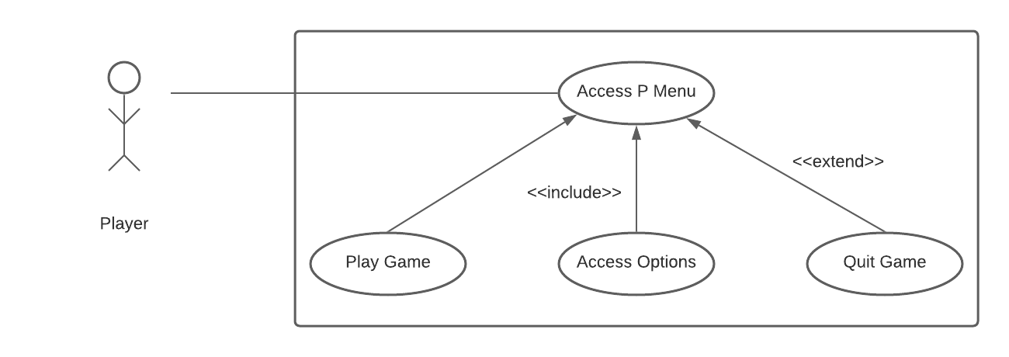

### Scenarios

**Name:** Play Game

**Summary:** The player wants to play the game.

**Actors:** Player

**Preconditions:** The application has been launched.

**Basis Sequence:**

**Step 1:** Accepts mouse input on the [play] button.

**Exceptions:**

**Step 1:** [Quit] is pressed before any input: Exit Game.

**Post conditions:** The first level is launched.

**Priority:** 2*

**ID:** M01

**Name:** Change Settings

**Summary:** The player launches the game and adjusts settings before playing the game.

**Actors:** Player

**Preconditions:** The game has been launched.

**Basic sequence:**

**Step 1:** Accept mouse input on [options] button.

**Step 2:** Navigate to Options Menu.

**Step 3:** Accept mouse input on Options Menu.

**Step 4:** Accept mouse input on [Back] button.

**Step 5:** Navigate to Main Menu.

**Step 6:** Accept mouse input on [play] button.

**Step 7:** Launch level 1.

**Exceptions:**

**Step 1:** [Quit] is pressed before any input: Exit Game.

**Step 5:** [Quit] is pressed after options are set: Exit Game.

**Post conditions:** Level 1 is launched.

**Priority:** 2*

**ID:** M02

**Name:** Quit game

**Summary:** The player quits the game before setting options or playing the game.

**Actors:** Player.

**Preconditions:** Game is launched.

**Basic Sequence:**

**Step 1:** Accept mouse input on [quit].

**Exceptions:**

**None**

**Post conditions:** Application is closed.

**Priority:** 2*

**ID:** M03

## Data Flow diagram(s) from Level 0 to process description for your feature _______14

### Data Flow Diagrams

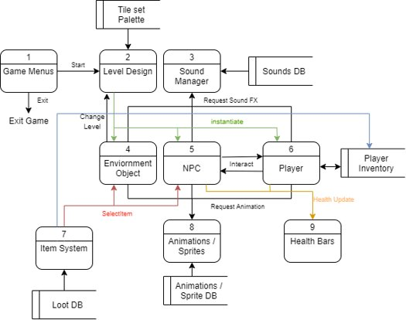

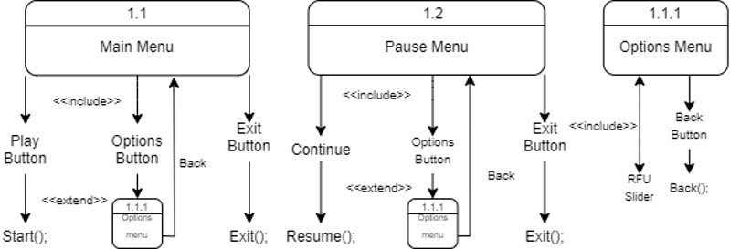

### Process Descriptions

Main menu selections*:

IF play is selected

Launch first level

IF options is selected

GOTO Options Menu

IF quit is selected

Exit application

Pause Menu selections*:

IF continue is selected

Resume game play

IF options is selected

GOTO Options Menu

IF exit is selected

GOTO Main Menu

Options Menu selections*:

IF slider is used

update volume level values

IF back button is selected

GOTO Main Menu

## Acceptance Tests ________9

**Testing Play Button**

Write a script that will click the play button 100 times. Each time, the script will log a debug message to an output file that displays which level is loaded in. (This will ensure that the correct level is generated each time the play button is pressed.

The output file will have the following characteristics:

* Total times test was ran (using a count() function)
* How many times the test produces “level 1 launched” message (using count() function)
* Each individual debug message below total

**Testing Options Button**

Write a script that will click the options button 100 times. Each time, the script will log a debug message to an output file that displays the message “Options Menu”, if the current active game object in the scene is the Options Menu.

The output file will have the following characteristics:

* Total number of times the test was ran (using a for loop most likely)
* How many times the test produces the options menu as the active game object (using for loop most likely)
* Each individual debug message

**Testing Quit Button**

Write a script that will click the quit button 100 times. Each time, the script will log a debug message to an output file that displays the message “QUIT!”.

The output file will have the following characteristics:

* Total number of times the test was ran (using a for loop most likely)
* How many times the test produces “QUIT!” as a debug message (using count() function)
* Each individual debug message

## Timeline _________/10

### Work items

|  |  |  |
| --- | --- | --- |
| Task | Duration (Hours) | Predecessor Task(s) |
| 1. Basic Menu Layout/Data Flow | 2 | - |
| 2. Menu Functionality | 3 | 1 |
| 3. Menu Design | 4 | 1 |
| 4. Stylistic Elements | 5 | 2, 3 |
| 5. Documentation | 2 | 4 |
| 6. Testing/Implementing Tests | 5 | 4 |
| 7. Finalization | 2 | 6 |
| 8. Connect to the game | 1 | 5, 7 |

### Gantt timeline

|  |  |  |  |  |  |  |  |  |  |  |  |  |  |  |  |  |  |  |  |  |  |  |  |  |
| --- | --- | --- | --- | --- | --- | --- | --- | --- | --- | --- | --- | --- | --- | --- | --- | --- | --- | --- | --- | --- | --- | --- | --- | --- |
| 1 |  |  |  |  |  |  |  |  |  |  |  |  |  |  |  |  |  |  |  |  |  |  |  |  |
| 2 |  |  |  |  |  |  |  |  |  |  |  |  |  |  |  |  |  |  |  |  |  |  |  |  |
| 3 |  |  |  |  |  |  |  |  |  |  |  |  |  |  |  |  |  |  |  |  |  |  |  |  |
| 4 |  |  |  |  |  |  |  |  |  |  |  |  |  |  |  |  |  |  |  |  |  |  |  |  |
| 5 |  |  |  |  |  |  |  |  |  |  |  |  |  |  |  |  |  |  |  |  |  |  |  |  |
| 6 |  |  |  |  |  |  |  |  |  |  |  |  |  |  |  |  |  |  |  |  |  |  |  |  |
| 7 |  |  |  |  |  |  |  |  |  |  |  |  |  |  |  |  |  |  |  |  |  |  |  |  |
| 8 |  |  |  |  |  |  |  |  |  |  |  |  |  |  |  |  |  |  |  |  |  |  |  |  |
|  | 1 | 2 | 3 | 4 | 5 | 6 | 7 | 8 | 9 | 10 | 11 | 12 | 13 | 14 | 15 | 16 | 17 | 18 | 19 | 20 | 21 | 22 | 23 | 24 |